**Purpose:**

Build a small simple showcase lab in order to test the upcoming MSIX App Attach feature.

More info in the [official documentation](https://docs.microsoft.com/en-us/azure/virtual-desktop/app-attach) and [Azure Academy youtube video](https://www.youtube.com/watch?v=6kkPLFgPaN8)

**Disclaimer:**

All sample scripts are provided for illustrative purpose and are based on my test environment and they don’t represent official Microsoft best practices.

**Useful links:**

[Official Documentation](https://docs.microsoft.com/en-us/azure/virtual-desktop/app-attach)

[Azure Academy video](https://www.youtube.com/watch?v=6kkPLFgPaN8)

First of all we need the last Windows 10 2004 so you can install it on a physical machine, a virtual machine hosted by Hyper-V, VMware, Azure, AWS… It doesn’t matter because MSIX app attach is a Windows 10 feature and is not linked with some specific feature available only on Windows Virtual Desktop.

Then you can download the scripts.zip file that you can fine in my Github repository

<https://github.com/mmoioli/WVD/tree/master/MSIX%20Lab>

Inside the Windows 10, **create a C:\MSIX directory** and **copy the** **Scripts.zip** file and extract the files inside

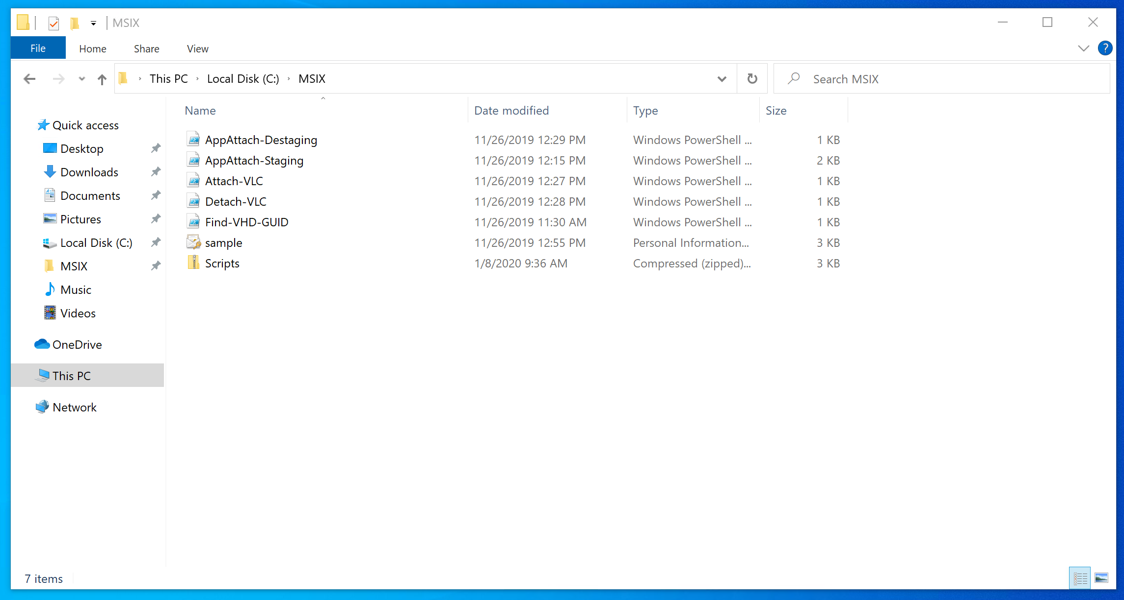

Download/Copy the installation files for an application like Notepad++

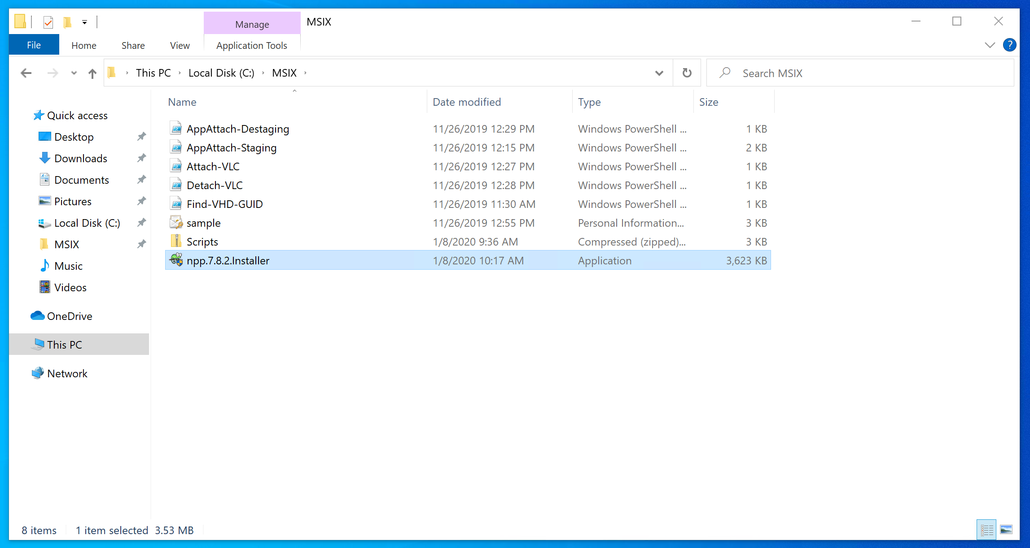

Open the Store App and search for MSIX Packaging Tool

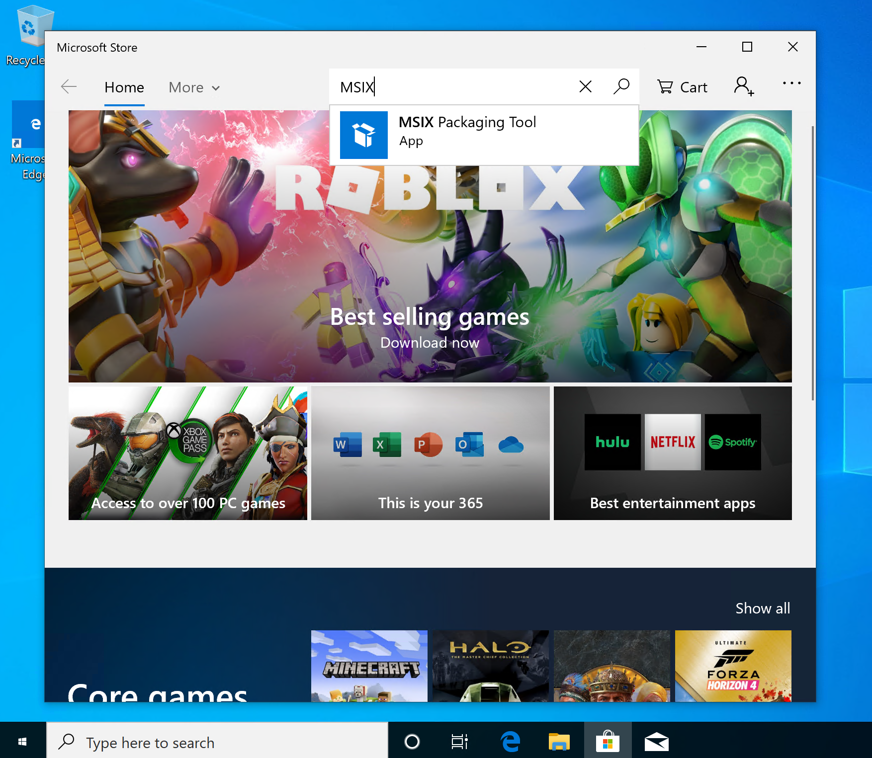

Install It

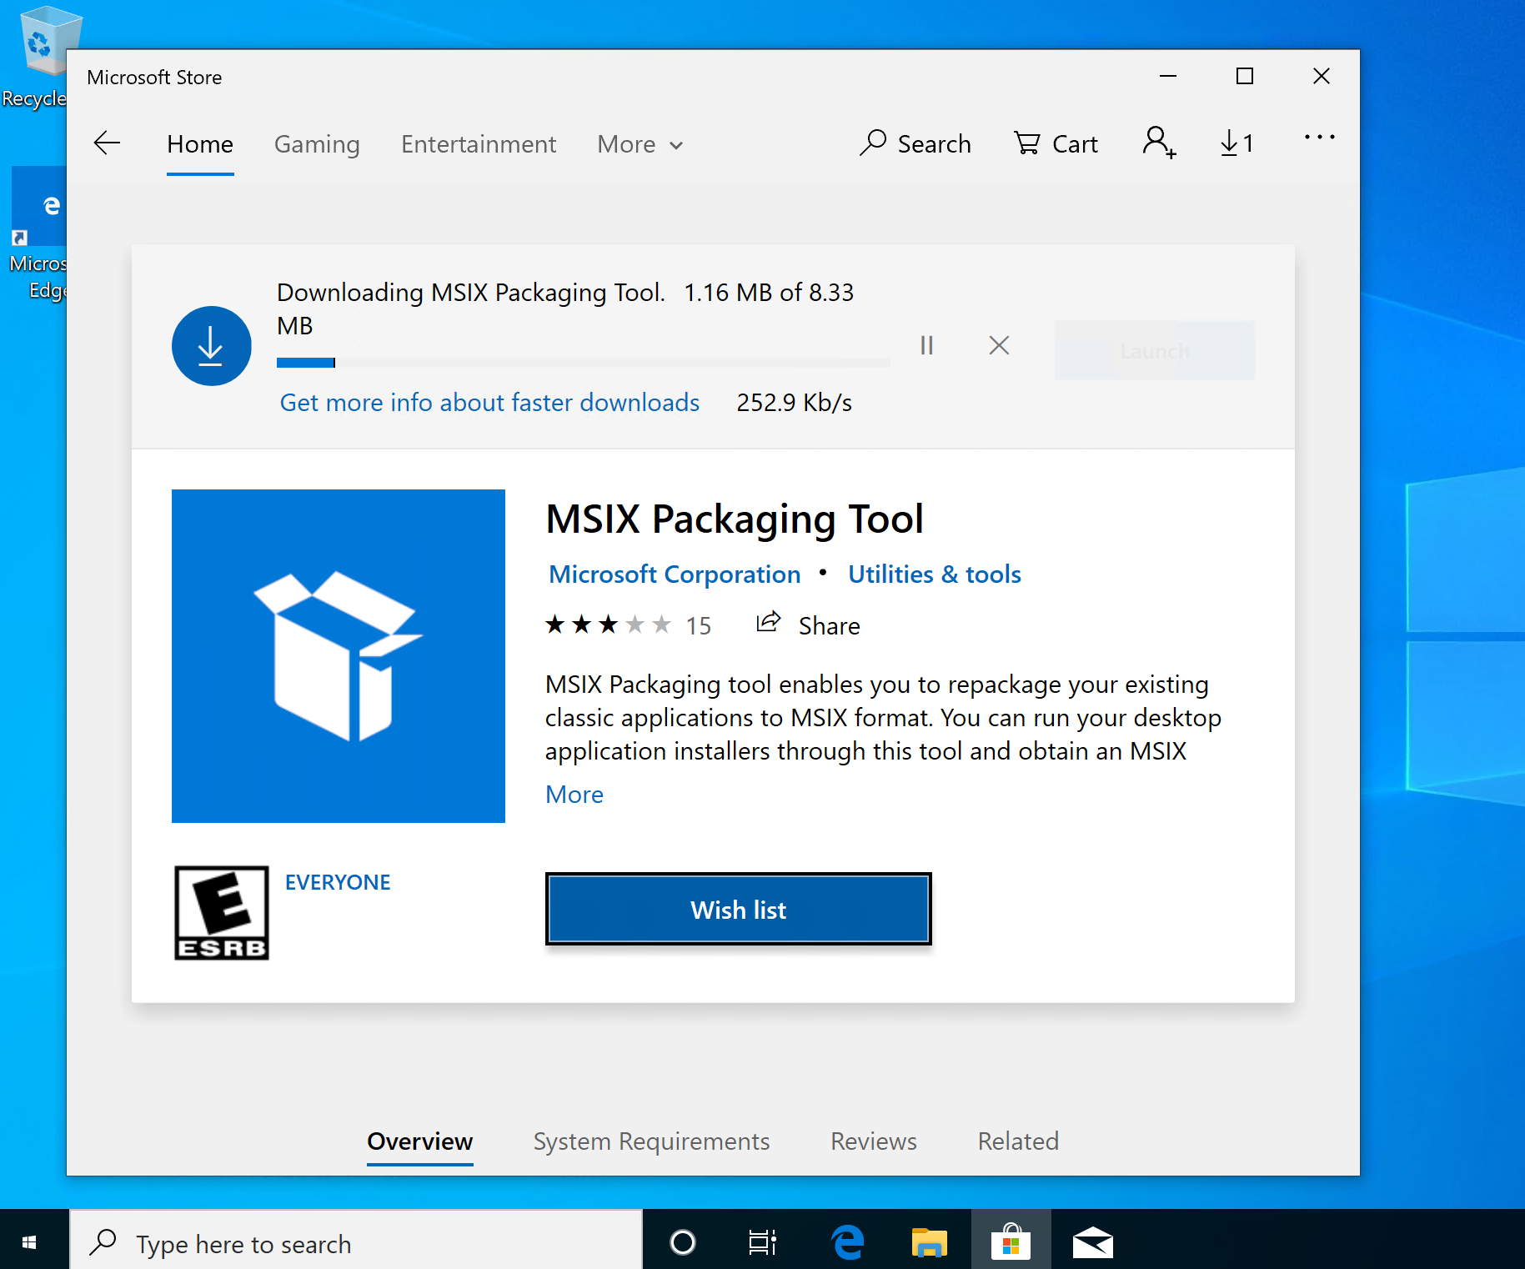

Open the app MSIX Packaging Tool and click on the wheel

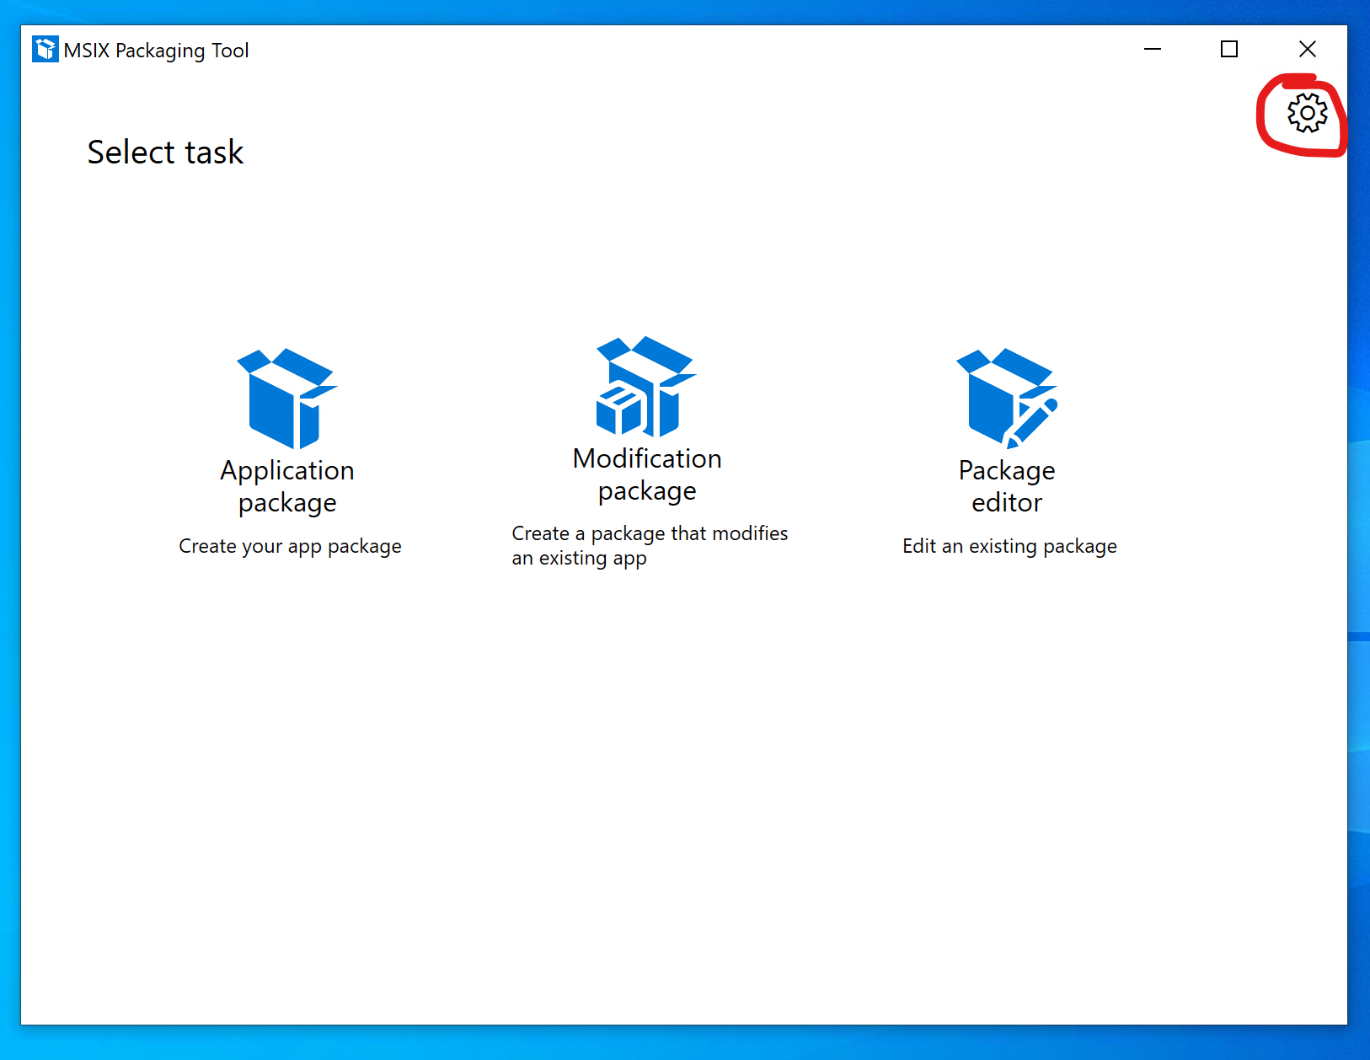

Select “Sign with a certificate (.pfx)”, Select the “sample.pfx” certification that you find in C:\MSIX and use the “MSIX!” password

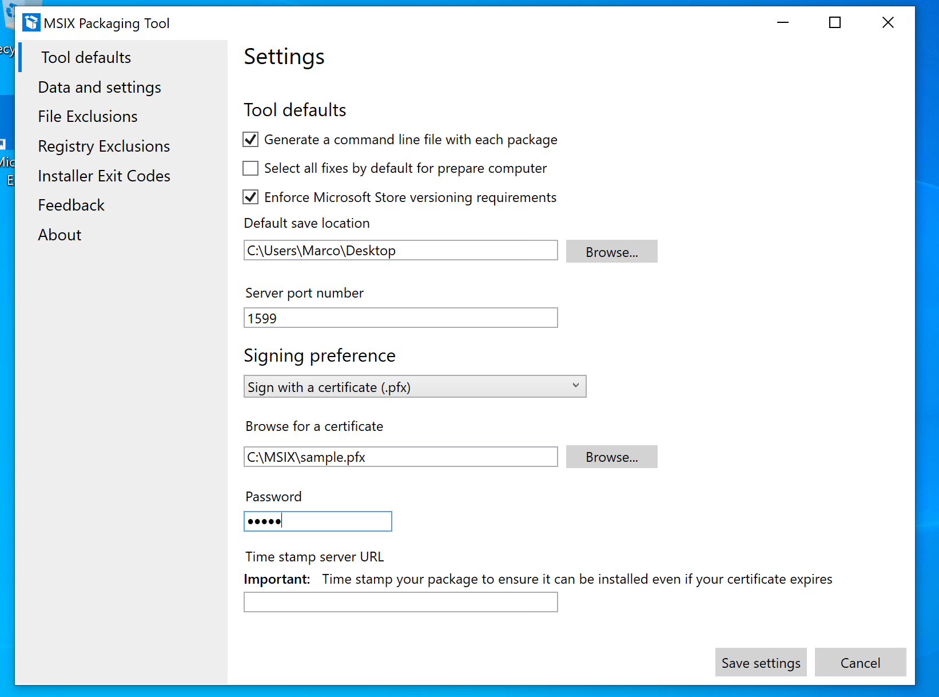

From the MSIX Packaging Tool click on “Application package”

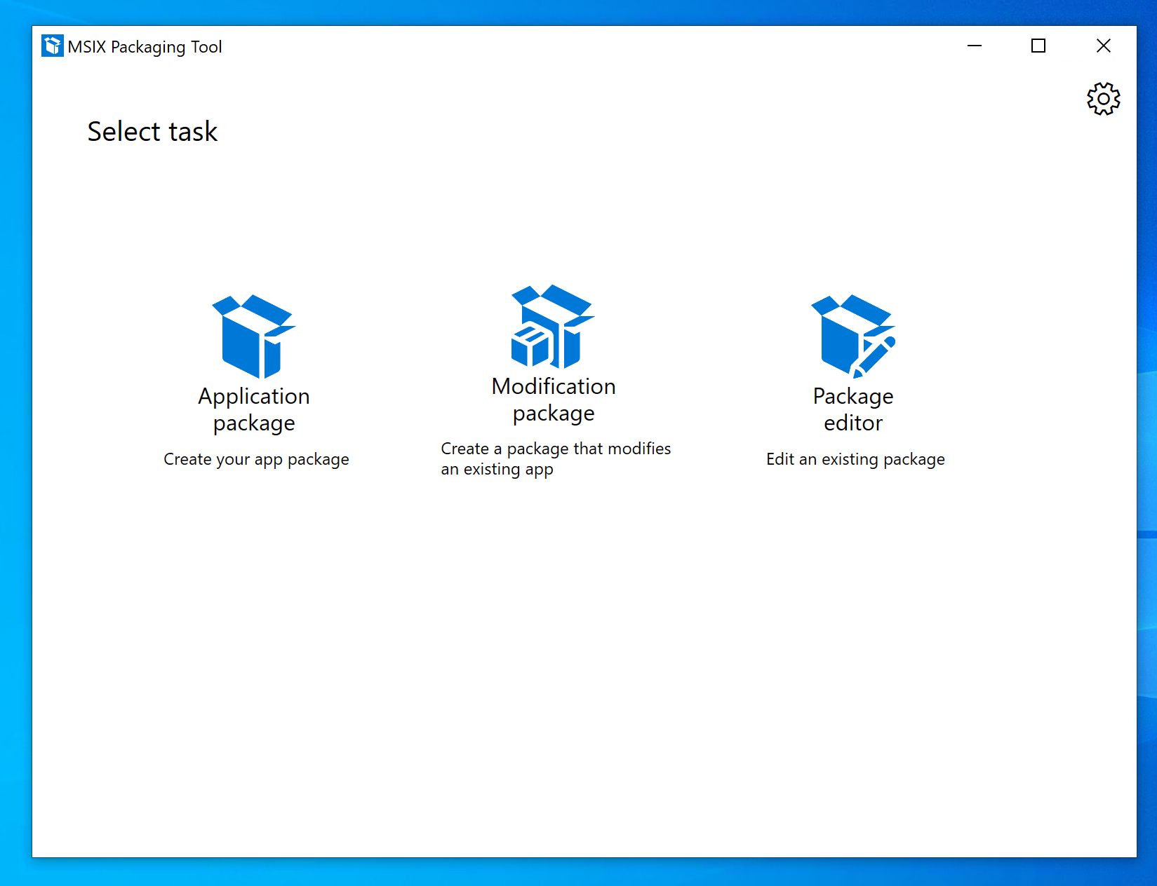

Next

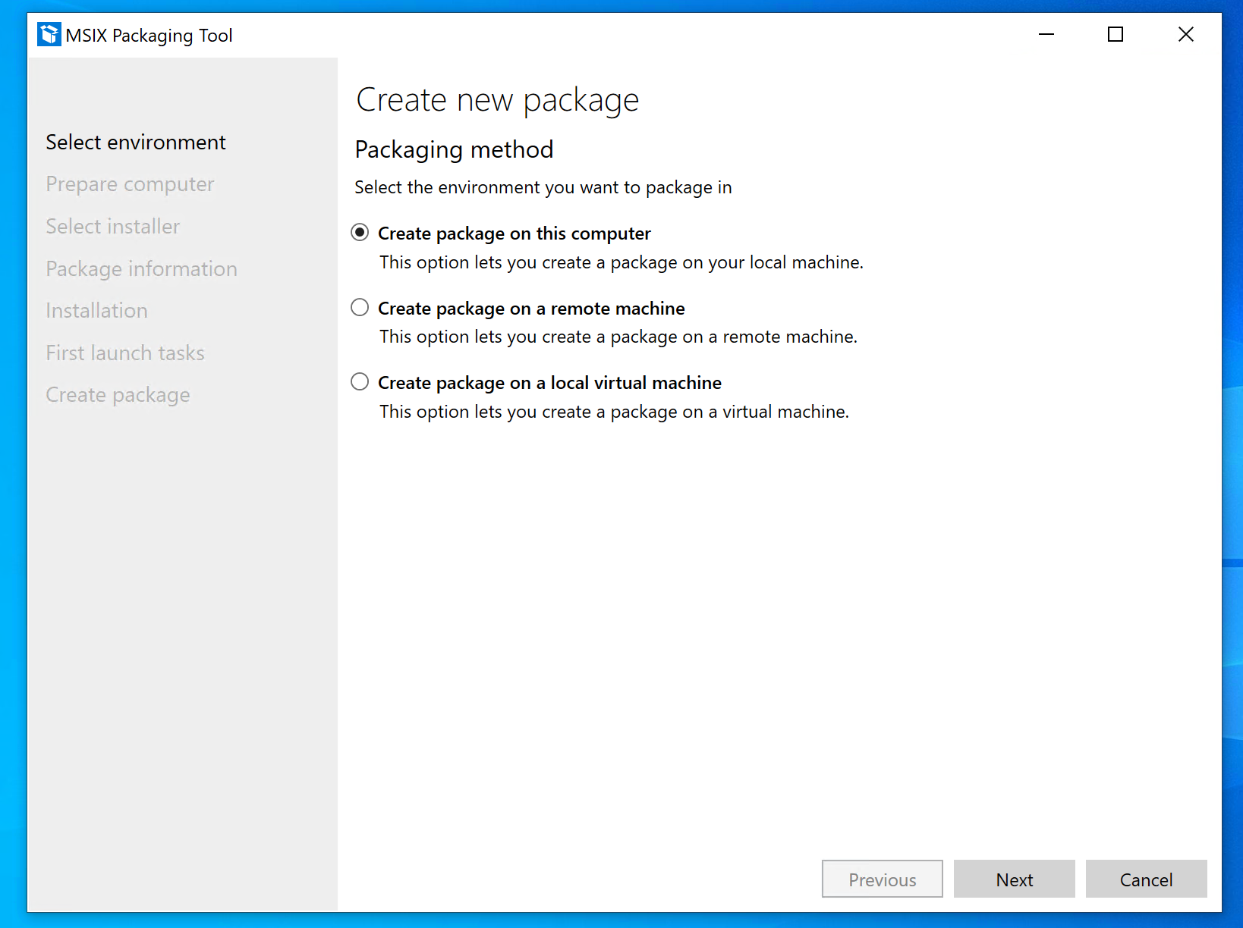

Click on every “Recommended action items” and on “Disable selected”

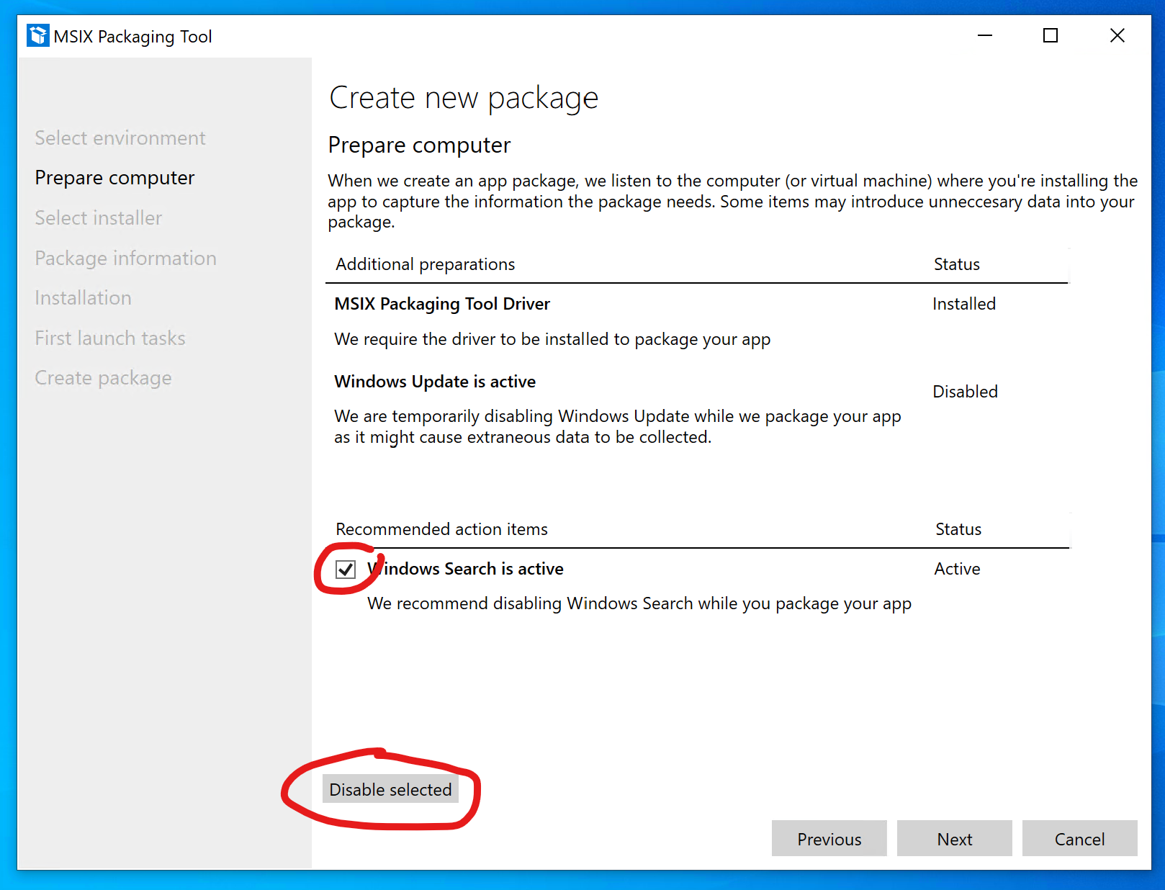

Select the Notepad++ installer

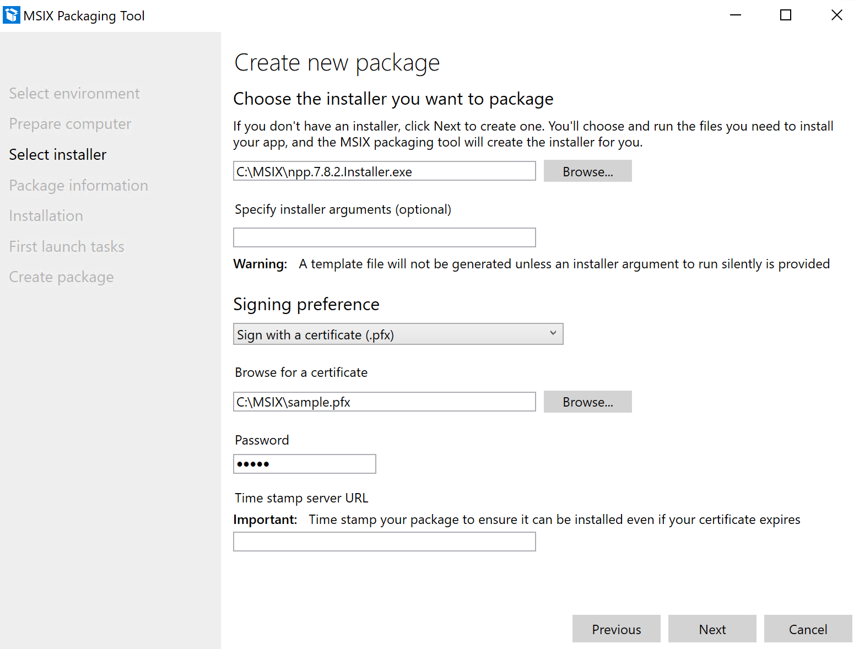

Insert the required package information

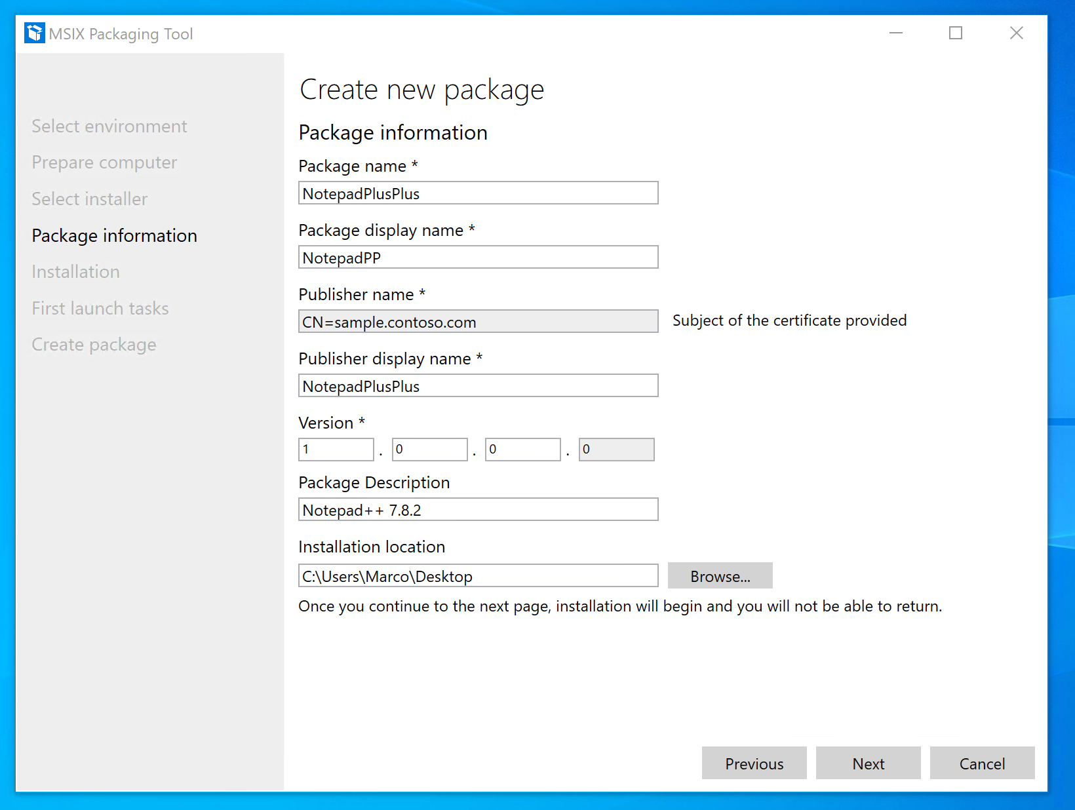

Now go through the installation process

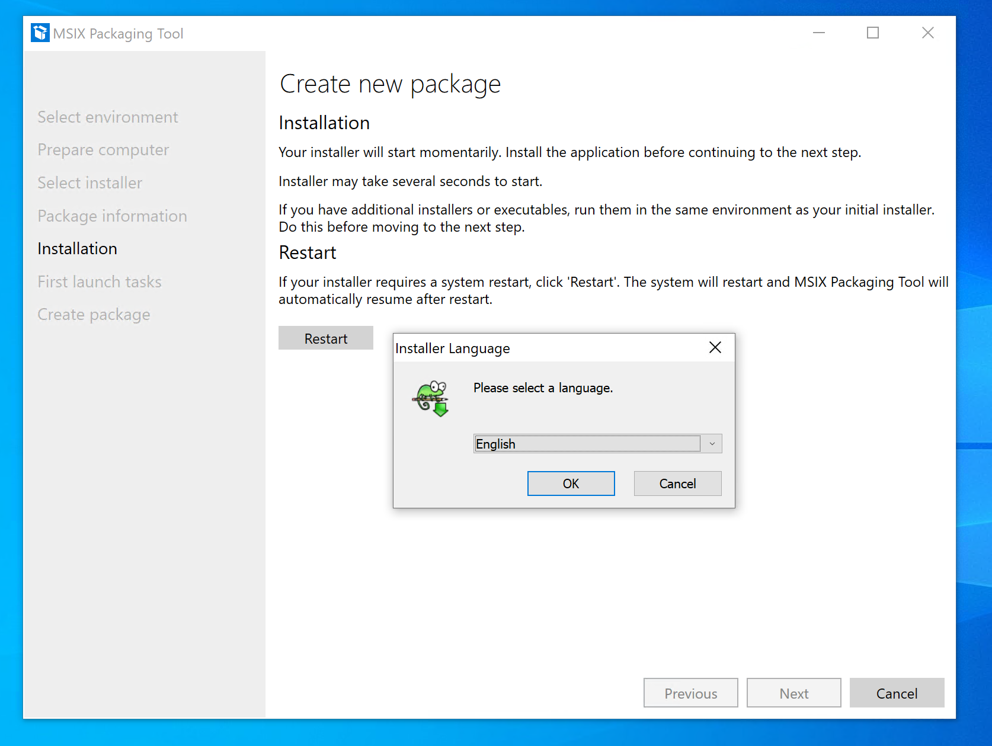

Launch one time the application in order to capture everything

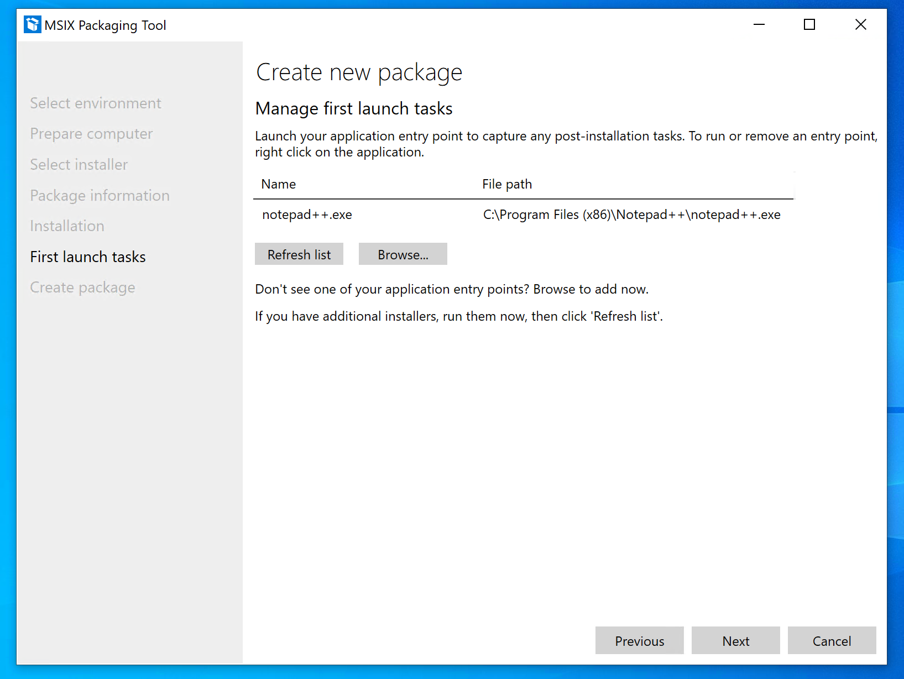

End the sequencing clicking on “Yes, move on”

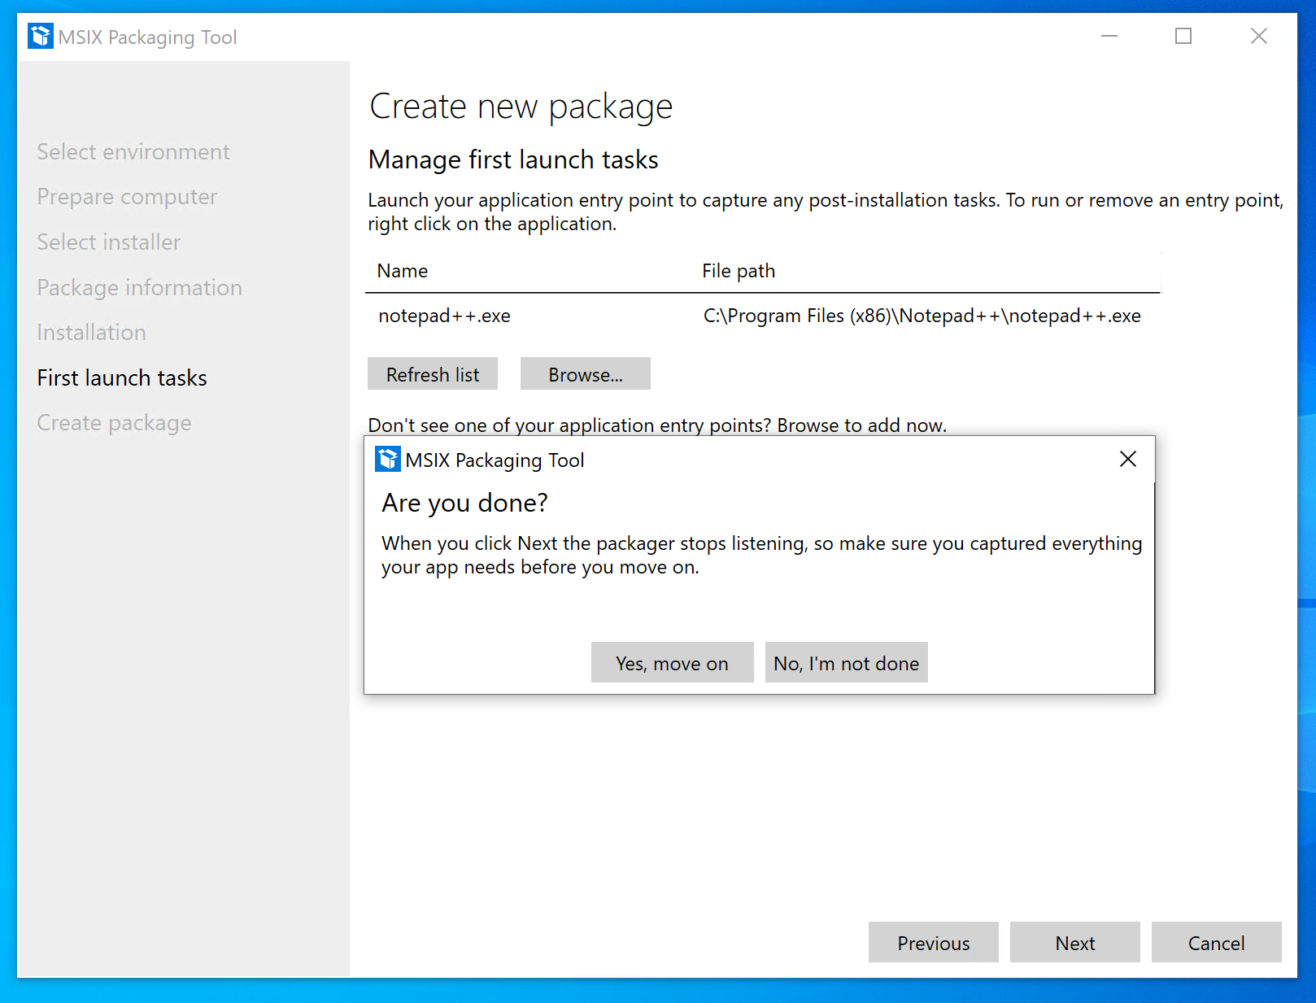

Save the package in C:\MSIX

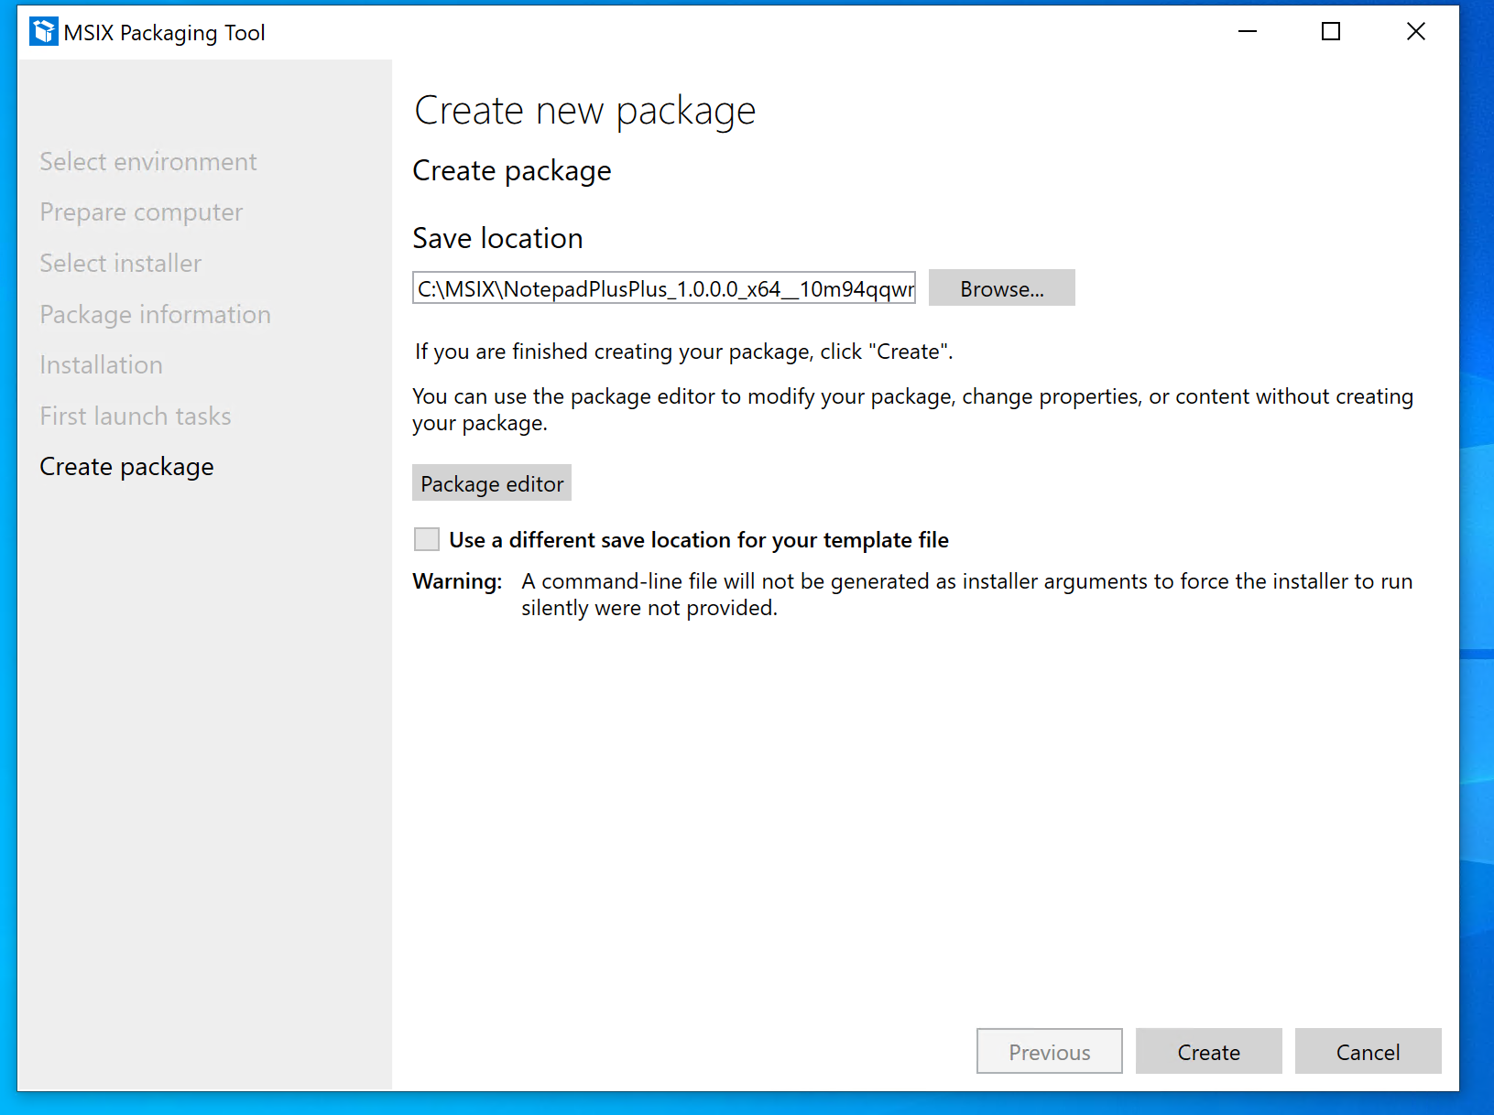

Now you can uninstall Notepad++ from Windows

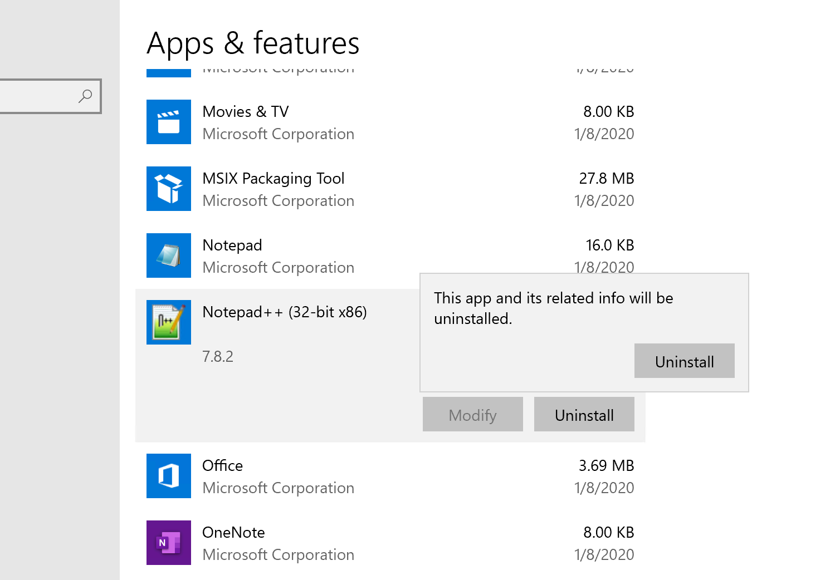

Double click **C:\temp\sample.pfx** and select **“Local Machine”**

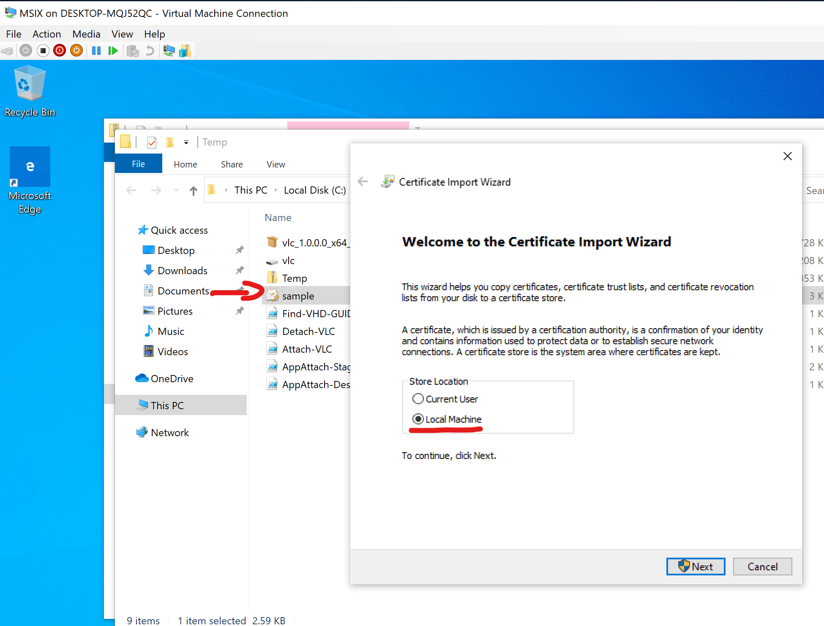

The password is “MSIX!”

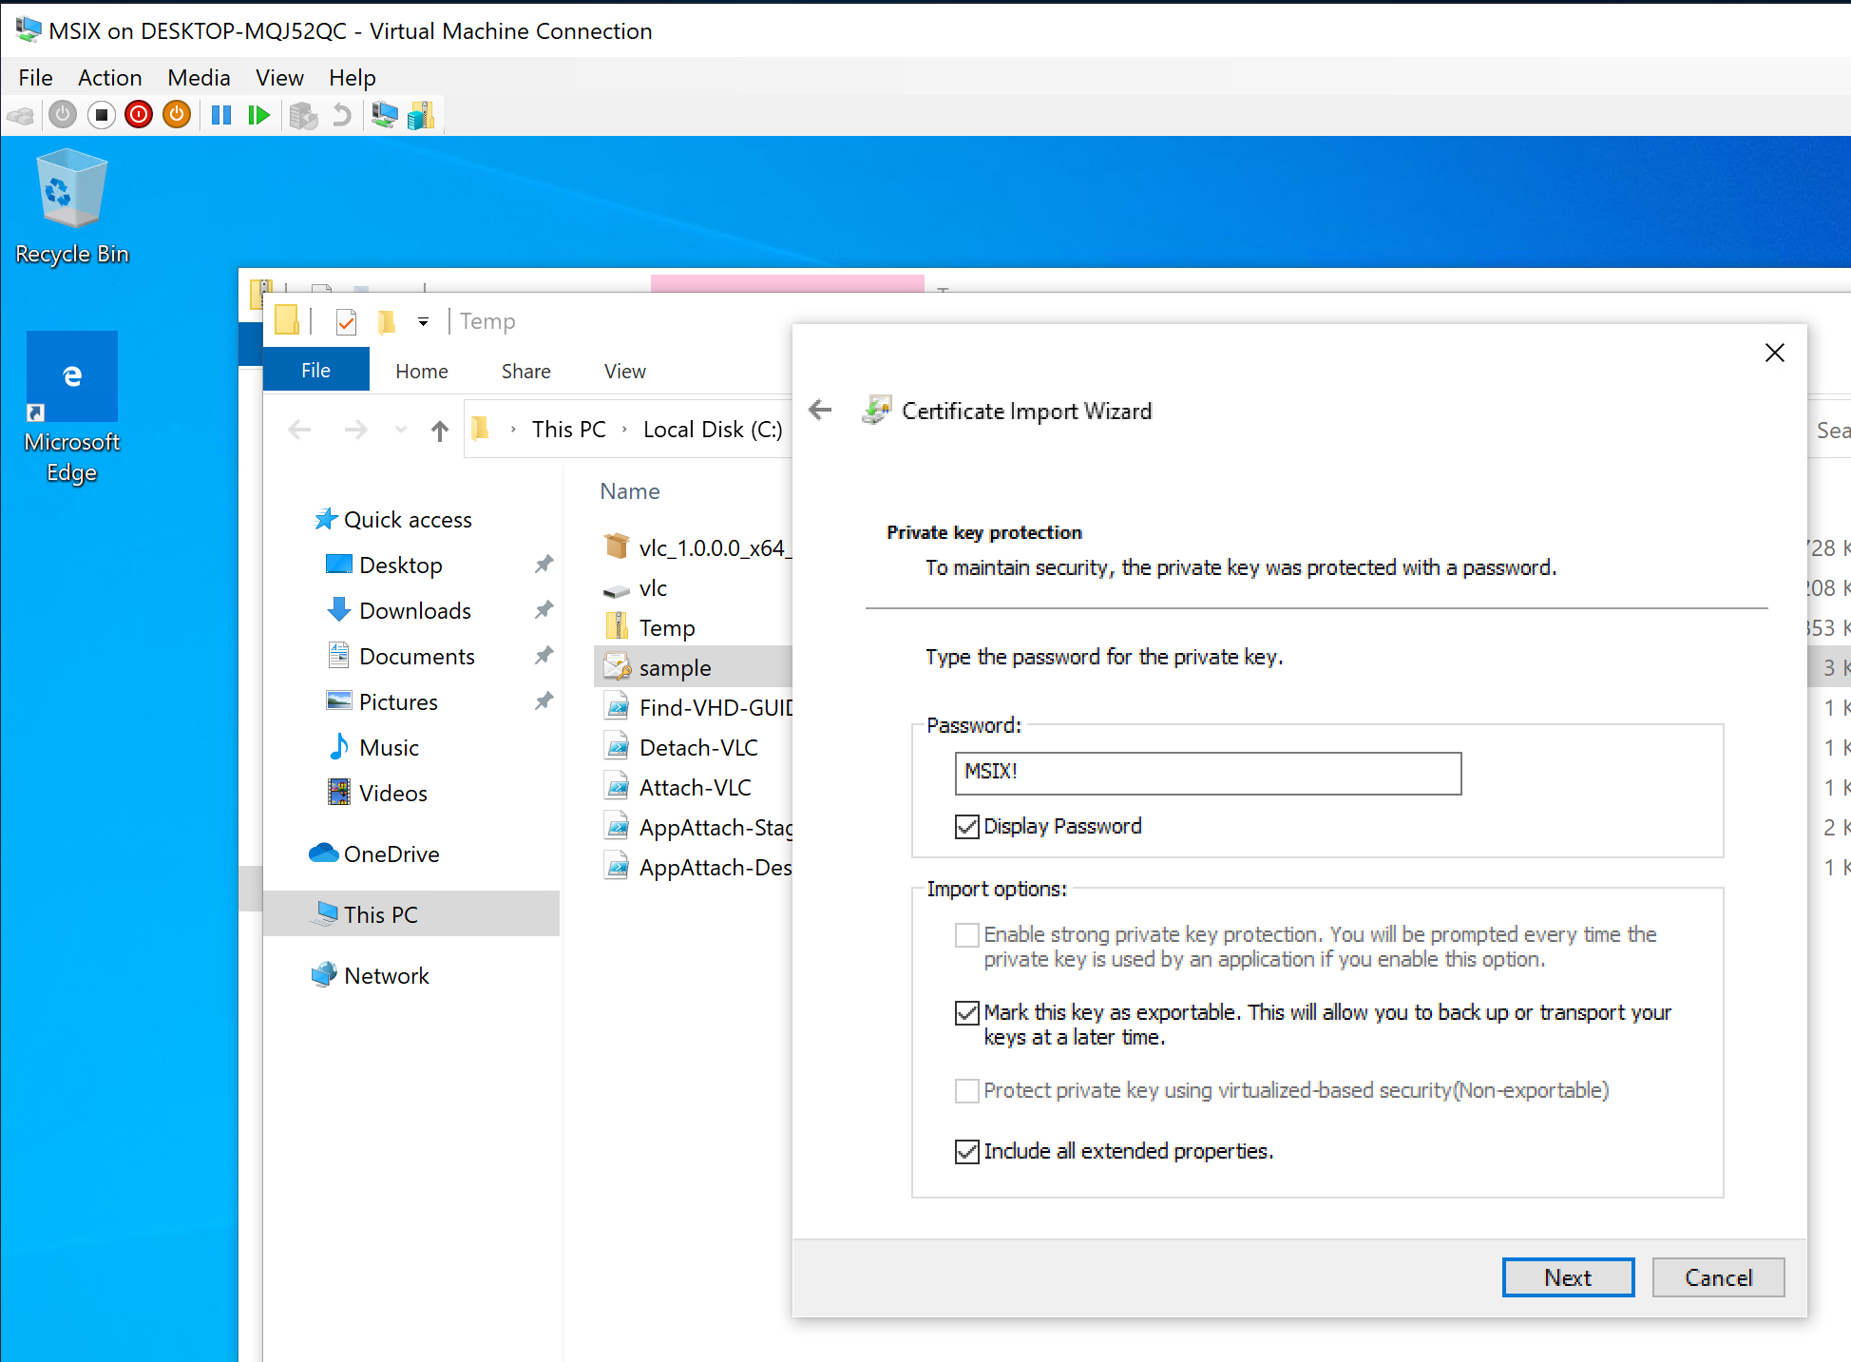

Place it in **“Trusted Root Certification Authorities”**

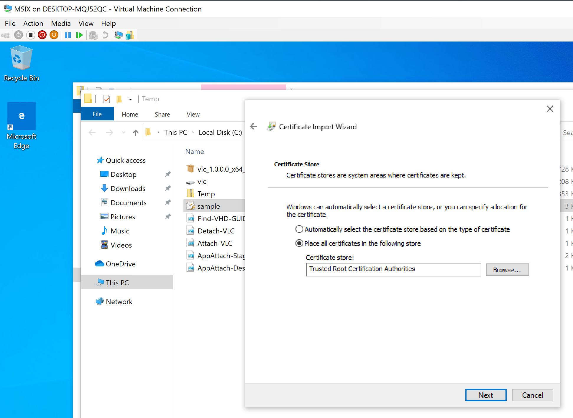

The certificate is a self signing certificate that I created using this command:

New-SelfSignedCertificate -DnsName sample.contoso.com -Type CodeSigning -CertStoreLocation Cert:\CurrentUser\My

**Use it only in a lab environment not in production!!!**

The certificate is needed because when I created the MSIX package I signed it with this certificate.

So now you can try the MSIX package created: simply double click on it and install just to check that the MSIX package is good…

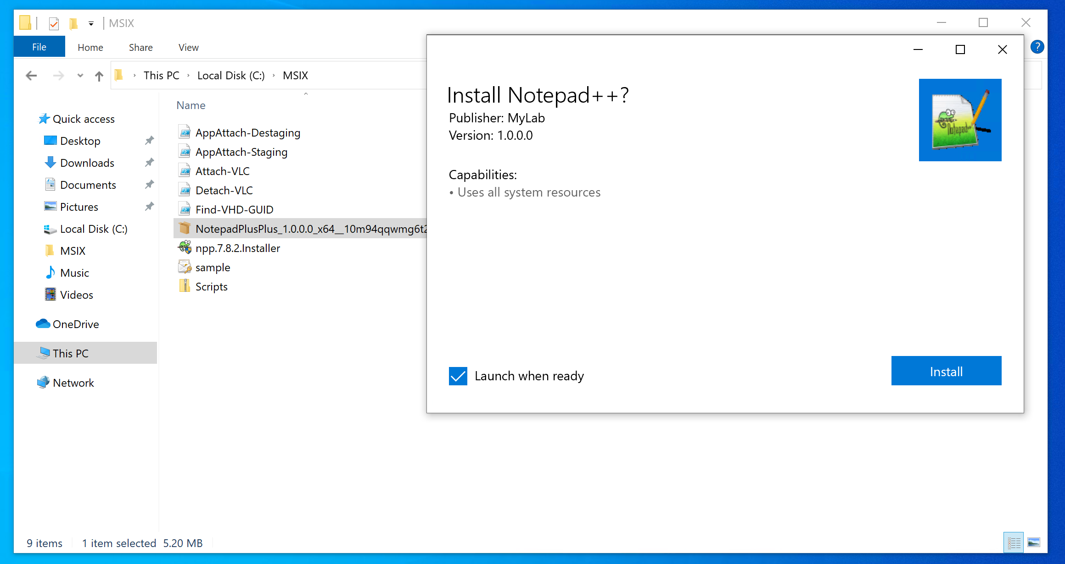

If everything is good you can use Notepad++ and you can uninstall it simply using a right click on the icon

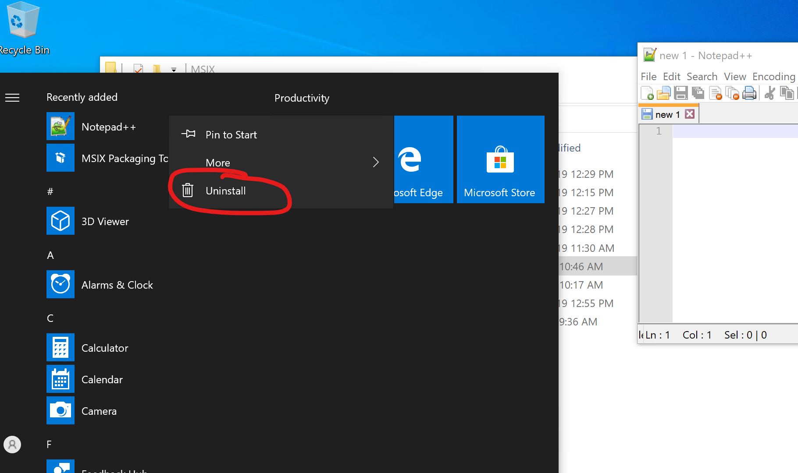

Ok now we have an MSIX package containing Notepad++ that is working but this is not AppAttach so let’s continue…

**Generate the VHD app package**

Download the last [msixmgr](https://aka.ms/msixmgr) tool and extract the files in C:\MSIX

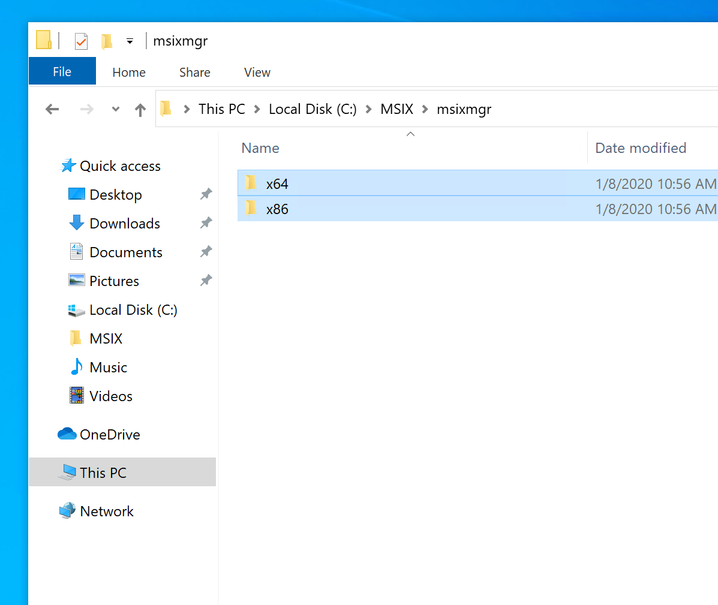

Now open diskmgr and Create a VHD

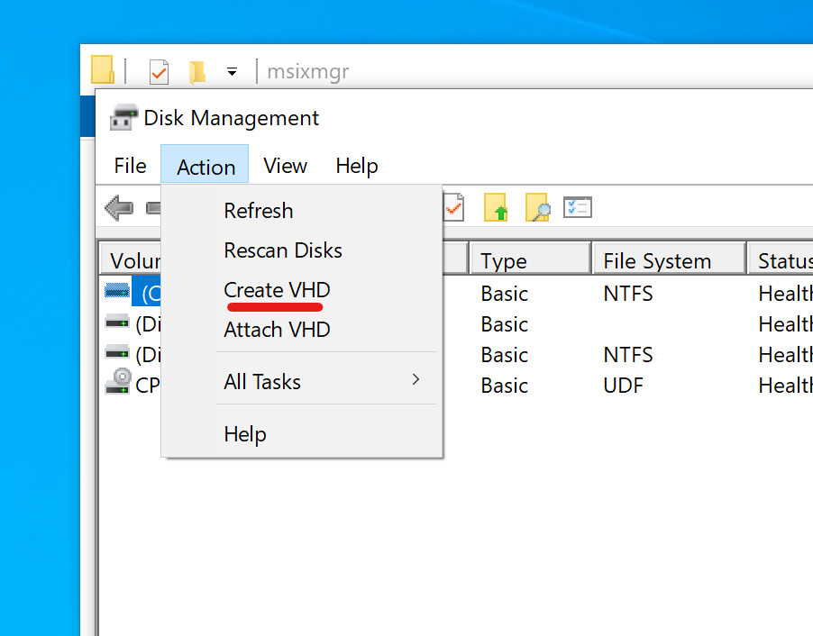

Create a Dynamically expanding VHD in C:\MSIX the size must be at least the size of the expanded MSIX package that we will insert

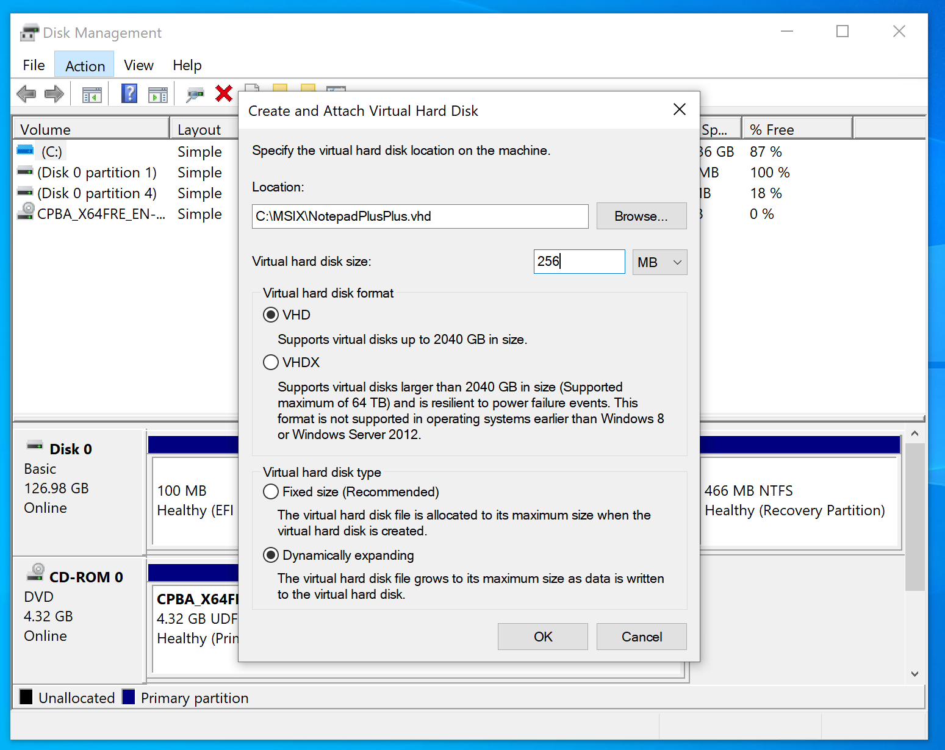

Now you can initialize the disk, create a partition and assign a letter like X

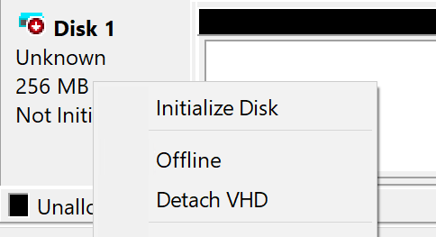

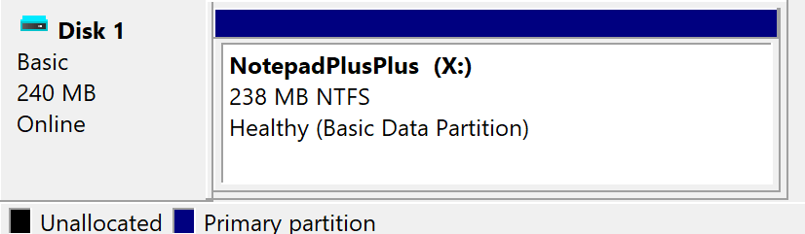

**VERY IMPORTANT!!!**

Create a folder inside the vhd the name is your choice, I used **X:\NotepadPlusPlus**

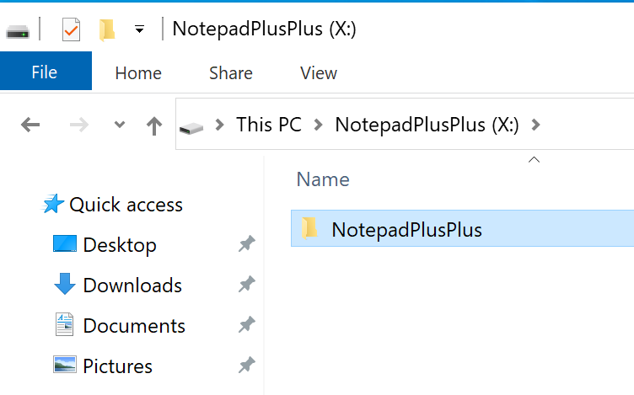

Open an elevated command prompt and type

*msixmgr.exe -Unpack -packagePath c:\MSIX\NotepadPlusPlus_1.0.0.0_x64__10m94qqwmg6t2.msix -destination x:\NotepadPlusPlus -applyacls*

**NOTE:** you must change the name of the msix package with the one generated by your packaging tool

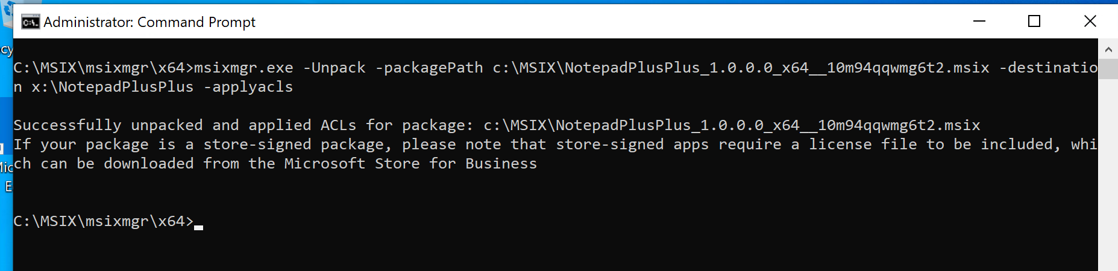

Now it’s Powershell time so open it as an administrator

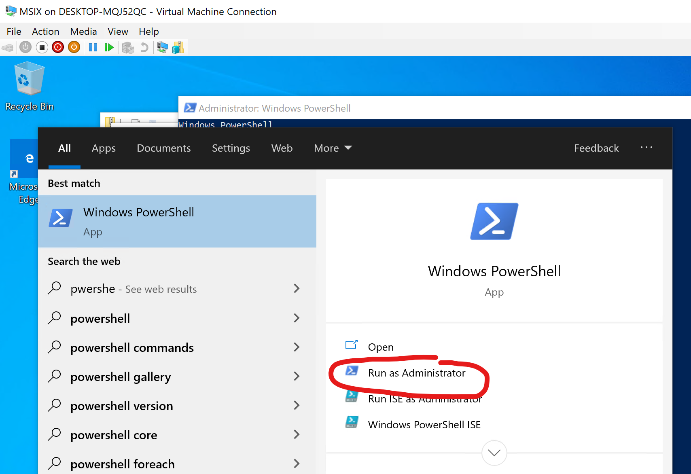

Just because this is a small and simple demo lab, I set the powershell execution policy as “Unrestricted”

Set-executionpolicy Unrestricted

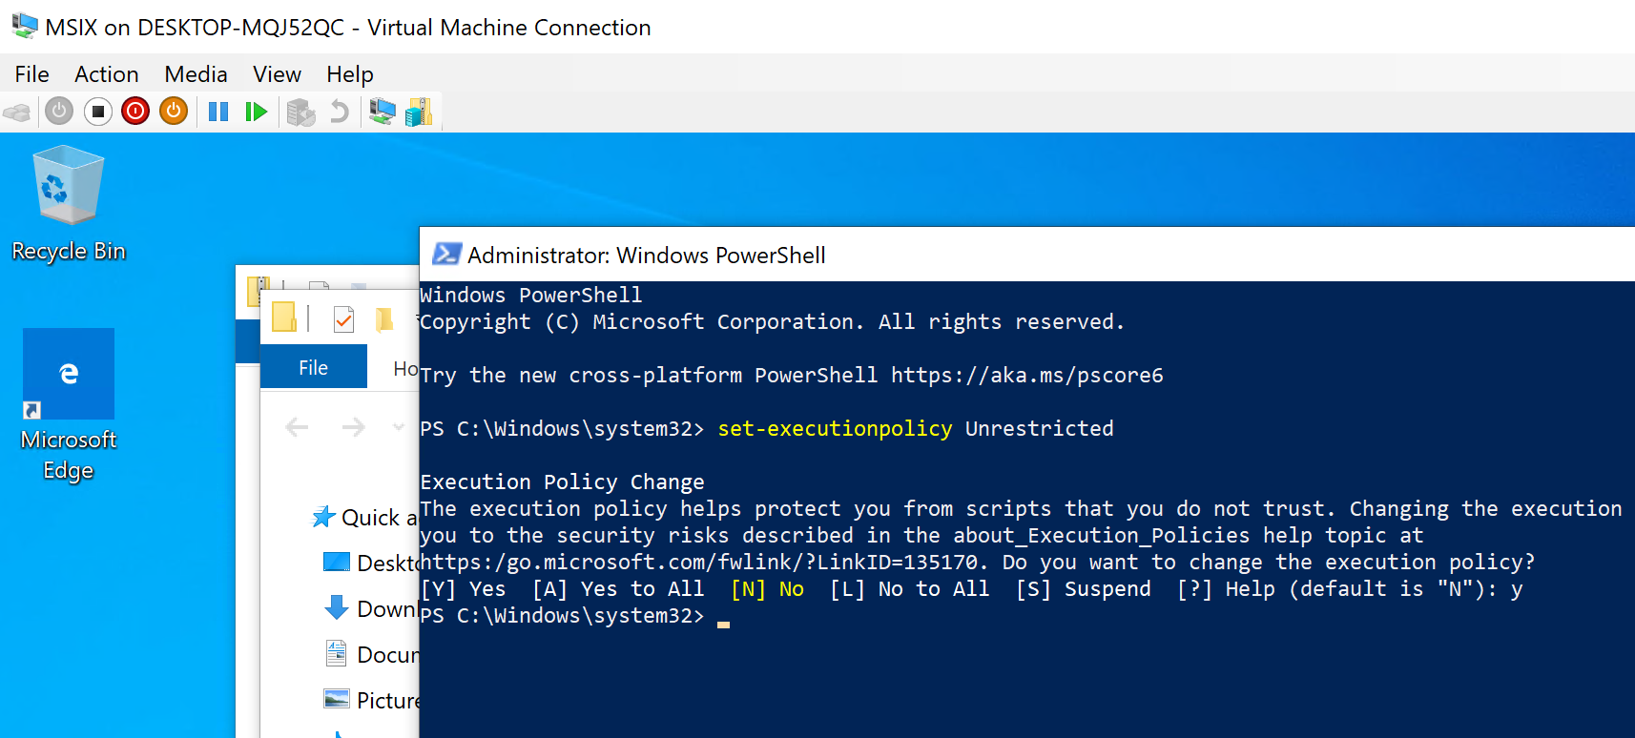

We need to retrieve the X: volume guid so the command is:

$volumeGuid = (((Get-volume -driveletter x).UniqueId).split('{')[1]).split('}')[0]

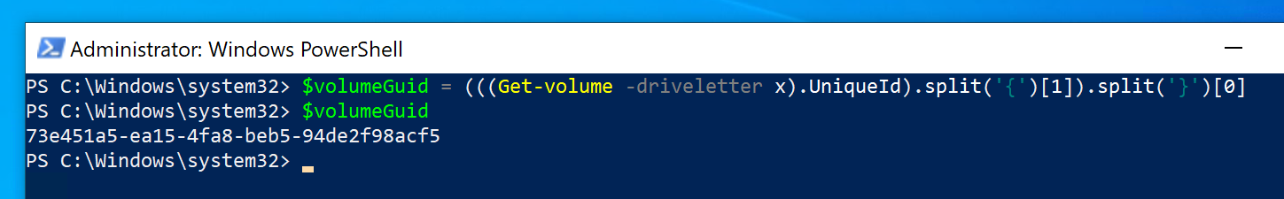

Now we can detach the VHD from the disk management tool

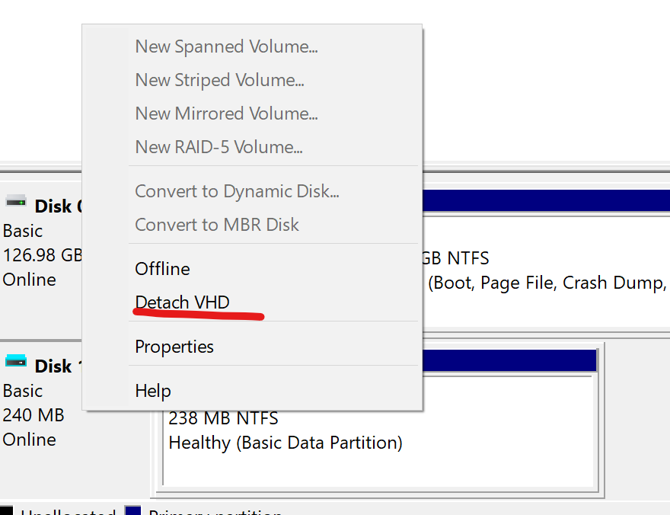

Create a Temp directory in C:

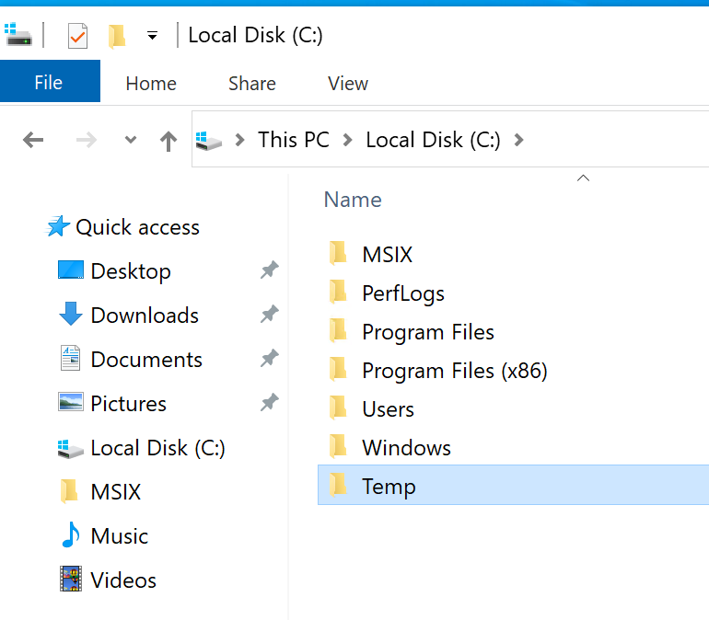

From C:\MSIX, run **.\AppAttach-Staging.ps1**

**NOTE:** be sure that the variables are matching the ones in your environment

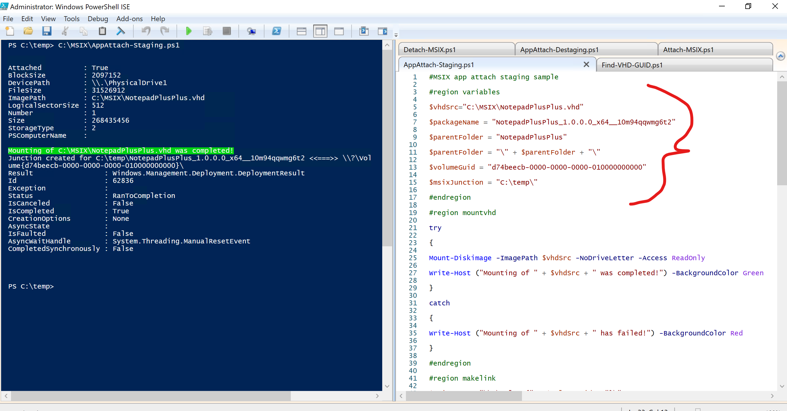

After you can run **.\Attach-MSIX.ps1** and in a moment you will find **Notepad++ in the Start menu**

**NOTE:** be sure that the variables are fitting your environment

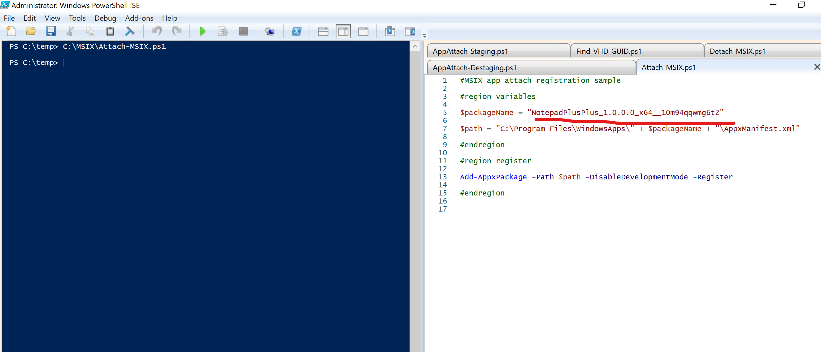

If you want to detach it simply run .\Detach-MSIX.ps1

If you want also to clean the staging environment, run .\AppAttach-Destaging.ps1

**NOTE:** before running the scripts, be sure that the variables are fitting your environment

If you are interested in understanding what exactly is the mechanism, I suggest you to watch the [Azure Academy video](https://www.youtube.com/watch?v=6kkPLFgPaN8) made by [Dean Cefola](https://github.com/DeanCefola).